# **TAX INVOICE** Date: 19/10/18 From: Eli’s Garden Improvements, 34a Windsor st Perth ABN: 29 312 028 484 To : Jan Lewis, Unit 6, 24 Canning Avenue, Mount Pleasant **Scope:** Usual garden maintenance Spray Seasol over entire garden

|  |  |  |  |
| --- | --- | --- | --- |
| **Qty** | **Description** | **Cost** |  |
| 4hrs | Labour | $140. | 00 |
| 1 | Seasol Powerfeed | $10. | 00 |
|  |  |  |  |
|  |  |  |  |
|  |  |  |  |
|  |  |  |  |
|  | **Total:** | **$150.** | **00** |

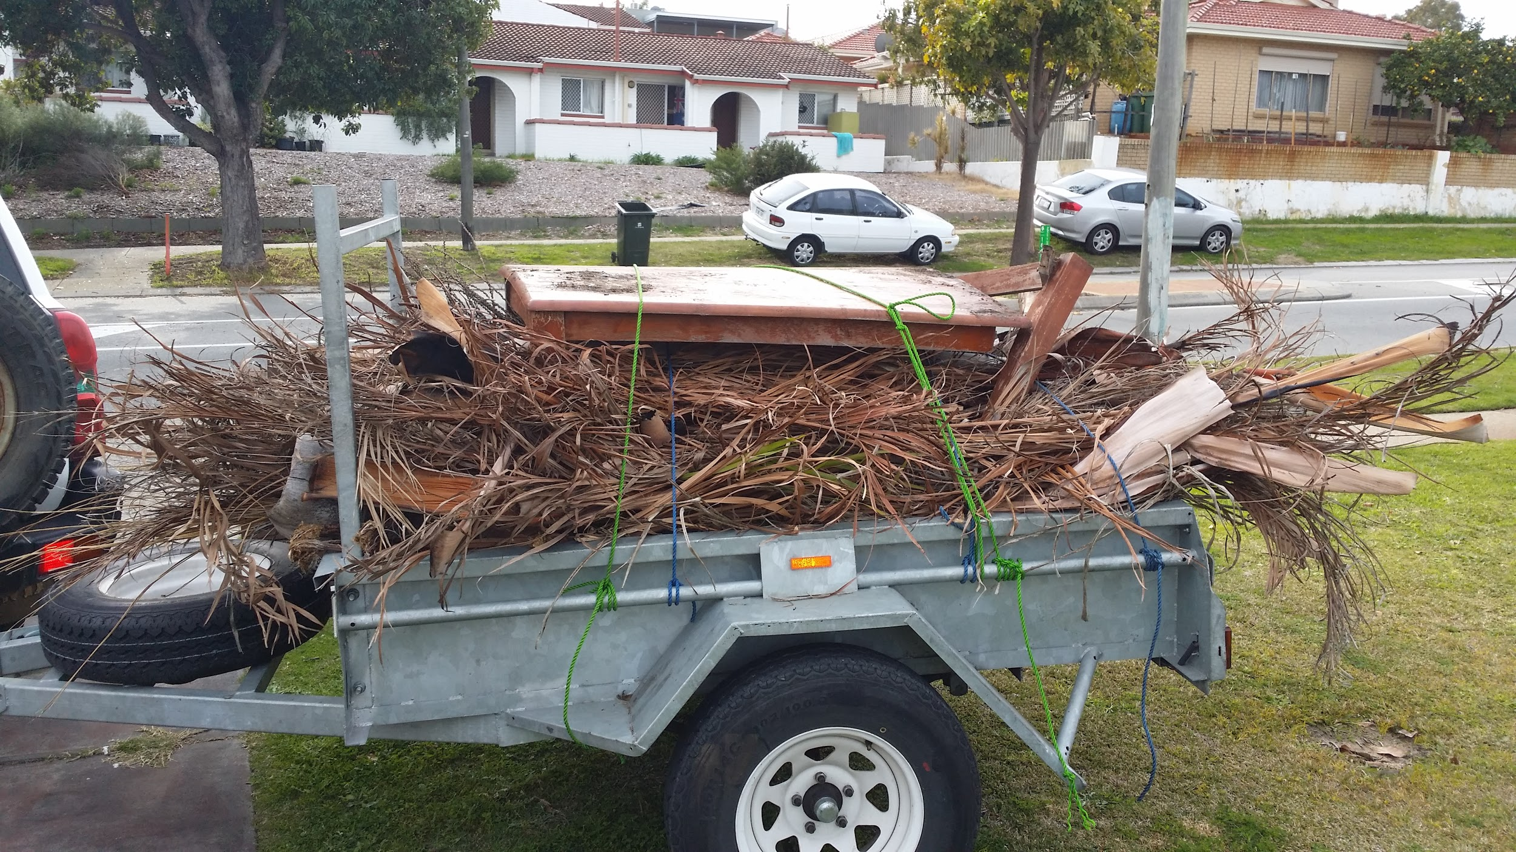

**Note**: **Please pay within 7 days.**  
Payment Details: Please Pay **$150.00**

NAB

Eli Simic Robertson

BSB:**086-006**

ACC: **831081868**